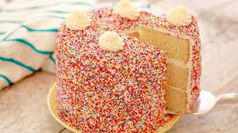
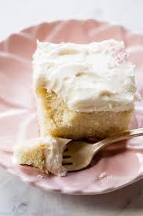
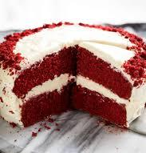
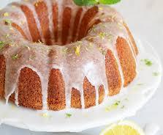
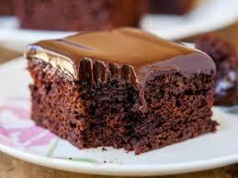
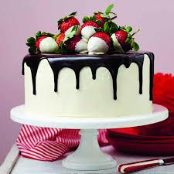
Amateur Baking Contest
May 1st, 2021
Contest Rules:
- This event is part of the annual downtown event Oasis Arts and Eats Fest.
- Professional bakers not permitted to enter. If you own/operate a food business, we invite you to fill out our restaurant vendor application!
- All bakers must submit 2 cakes, 1 for judging and 1 for silent auction to benefit the Foundation of Arts which will take place in Stage Too located @ 400 S Main on May 1st from 10:00-5:00. Judging will take place at a private location and entries will be ranked based on taste and presentation.
- Bakers are permitted to enter more than one cake, but must complete separate forms and pay entry fees for each.
- All bakers must drop off cakes between 9-10 in Stage Too in disposable baking pans or dishes. Please no entries that require refrigeration.
- Cakes for judging must be clearly labeled with baker’s name, category (layer, sheet, bundt), and title of entry. For silent auction, only a title of dessert label is required.
- One winner will be selected from each category with one “Best Overall”. Winners will be announced on the Centennial Plaza stage at 5:45. Silent auction winners may claim their cakes between 5:00-6:00.
- Prizes: Each category winner will receive a certificate and 2 tickets to an FOA production. Best Overall winner will receive a certificate, 2 tickets to an FOA production, a gift basket from Full Sun Gifts, AND their recipe will be featured on the Recovery Room’s menu during the month of May, 2021!
- Entry fee of $20 must be included at time of registration. You may enter by mail (send to 115 E. Monroe Jonesboro, AR 72401 Attn: Oasis Baking Competition, checks payable to The Foundation of Arts), or submit electronically at oasisartsandeats.com.
- Please fill out application below along with fee by April 15th, 2021. We look forward to tasting your recipes!
Baker’s Name: _______________________________________________
Email: ___________________________ Phone: _____________________
Type of entry: (please select one)
layer cake sheet cake bundt cake
Title of entry: (ie Black Forest, Triple Chocolate, Lemon Supreme, etc.)
____________________________________________________
Is there a special story behind your recipe you’d like to share? (ie a family tradition, happy accident, etc): ______________________________________________________________________
______________________________________________________________________
______________________________________________________________________

